NILEWOOD, a subsidiary of Valmore Holding, Advances Regional Expansion at Saudi Wood Show 2026
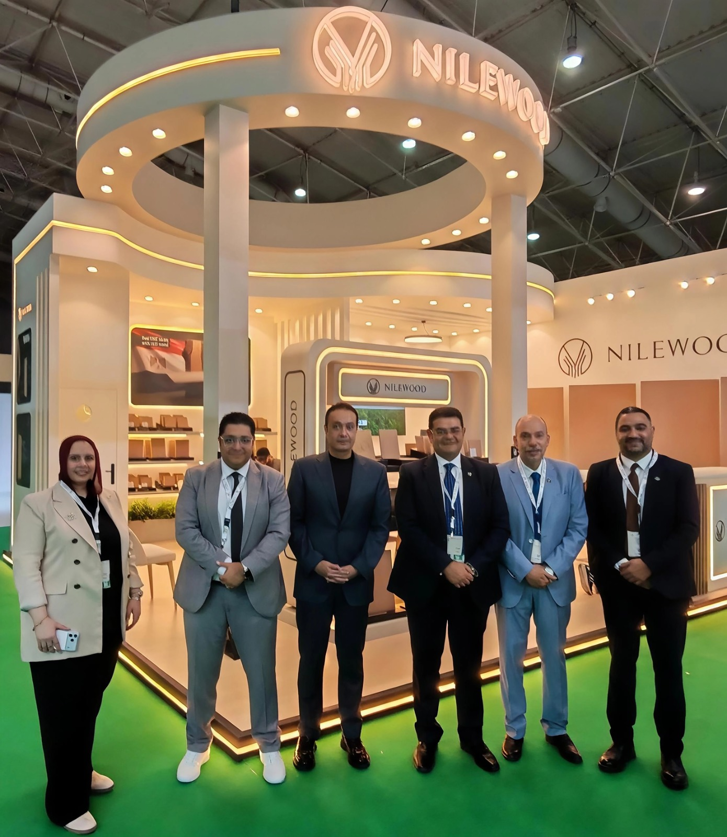
Cairo, 22 September 2026: NILEWOOD, a subsidiary of Valmore Holding and a manufacturer of medium-density fiberboard (MDF), participated as an exhibitor at Saudi Wood Show 2026, held in Riyadh from 1 to 3 September. The participation reflects NILEWOOD’s strategy to expand its regional footprint, grow its export business, and strengthen its positioning in high-potential markets. As part of this broader expansion journey, the company is focused on strengthening its presence in Saudi Arabia and across the GCC, while building stronger direct relationships with customers and partners in key regional markets.
NILEWOOD’s participation gains further significance given the growing prominence of Saudi Wood Show, which was held this year for its third edition under the patronage of Saudi Arabia’s Ministry of Industry and Mineral Resources. The 2026 edition attracted around 250 exhibitors from 54 countries and more than 14,000 visitors, reflecting the exhibition’s international reach and its role as a specialized platform bringing together manufacturers, suppliers, distributors, decision-makers and industry professionals from across the wood and related industries value chain.
Saudi Arabia represents an important market for the wood and MDF industry, supported by continued activity across construction, furniture, interior design, and real estate development. Against this backdrop, Saudi Wood Show provided NILEWOOD with a platform to engage directly with importers, distributors, furniture manufacturers, and project developers, among the stakeholders most closely aligned with the company’s export ambitions.
Nashed Adel, CEO of NILEWOOD, said: “Our participation in Saudi Wood Show 2026 reflects NILEWOOD’s commitment to strengthening its presence in strategic regional markets and expanding the reach of Egyptian-made MDF products. Saudi Arabia and the wider GCC are important markets within our regional growth strategy, and the exhibition provided us with a valuable platform to engage directly with importers, distributors, manufacturers, and project stakeholders, while gaining deeper insight into their needs and market developments. The participation also enabled us to explore new opportunities to develop sales and distribution channels and strengthen the value we provide to our customers, supporting our expansion across regional markets and sustainable export growth.”
Jon Rokk, CEO of Valmore Holding, commented: “At Valmore Holding, ‘Investing Beyond Capital’ means supporting our portfolio companies in developing their capabilities and strengthening their ability to expand and compete in new markets. NILEWOOD’s participation in Saudi Wood Show reflects this approach, creating opportunities to strengthen its regional presence and build relationships with customers and partners in new markets. We believe long-term sustainable value creation comes from enabling our portfolio companies to continue growing, expand their reach, and compete effectively in high-potential markets.”
It's worth noting that NILEWOOD, a subsidiary of Valmore Holding, specializes in the production of MDF in line with international quality standards. The company operates a state-of-the-art facility in Sadat City spanning 150,000 m², with an annual production capacity of 200,000 m³. Representing an investment of more than USD 100 million, the facility is equipped with advanced machinery from leading global manufacturers, including Dieffenbacher, Vyncke, and Andritz, and benefits from a strategic location supporting access to raw materials and export markets.

