H.E. Eng Tarek Al Molla recognizes Kuwait Energy Egypt in the Operational Excellence awards during the 8th EOG convention
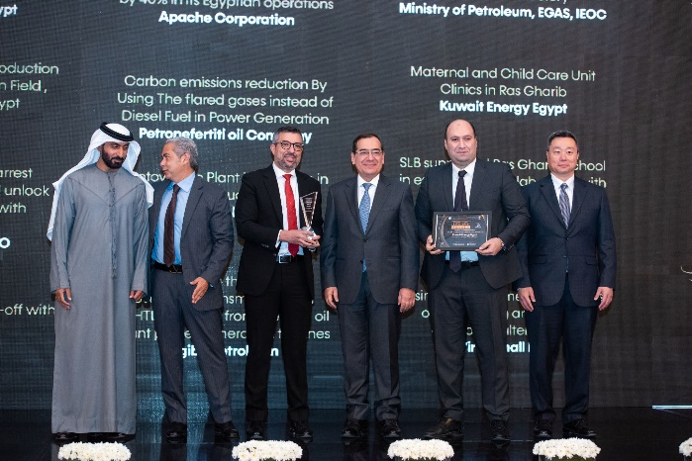 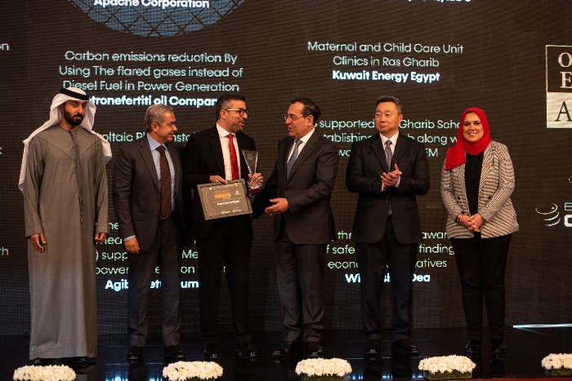
Kuwait Energy Egypt has been recognized two awards during 8th Egypt Oil and Gas Convention for the year 2022 that took place from 27-29 of November under the high patronage of H.E Eng. Tarek El Molla, Minister of Petroleum and Mineral Resources, part of the Egyptian Oil and Gas Sector Modernization Program. It is also worth mentioning that Kuwait Energy has sponsored this year’s convention as technical workshop sponsor.
For the third year in a row, H.E. Eng Tarek Al Molla has recognized Kuwait Energy Egypt for its operational excellence in running the business. This year, Kuwait Energy Egypt has collected the award for the best Brownfield award for Comprehensive Strategy handling challenging old brown fields and loose integrity wells in Eastern Desert and maximizing its potential via operationally standardized new innovative solutions. The award was handed out by His Excellency Tarek El Molla, Minister of Petroleum and Mineral Resources to Eng. Kamel Alsawi, President of Kuwait Energy Egypt and Eng. Mahmoud El Sayed, Senior Specialist Production Technology.
Additionally, Kuwait Energy Egypt has received an award for the best CSR project award for Maternal and Child Unit Clinics in Ras Gharib. The awarded project was implemented in collaboration with Misr El Kheir Foundation with a united long-term perspective of securing the highest standard of specialized healthcare to every child and mother in Ras Gharib with around 75,000 beneficiaries. The award was handed out by His Excellency Tarek El Molla, Minister of Petroleum and Mineral Resources to Eng. Kamel Alsawi, President of Kuwait Energy Egypt and Yasmin Ali, Corporate Affairs Manager.
As a top energy leader and a key speaker, Eng. Kamel Alsawi has participated in the strategic roundtable during the convention which was held to discuss the ways to secure a stable access to energy sources on a timely, sustainable and affordable basis.
Shedding the light on Technical Workshops during the convention which was exclusively sponsored by Kuwait Energy Egypt. Eng. Mahmoud Sayed has delivered presentation entitled “Challenging of Maximizing Brown Field Production in High Artificial Lift Failures Frequency Environment as a Result of Wells Harsh Conditions." which brought important updates in the industry.
It is worth remembering that Kuwait Energy Egypt has been selected previously in December 2019 and won the Operational Excellence Award for a project in its Western Desert concession as well as winning the Operational Excellence in Brownfield Award for “Rejuvenation of the Area A fields, Egypt, Challenges, Plans and Results” back in 2021.

