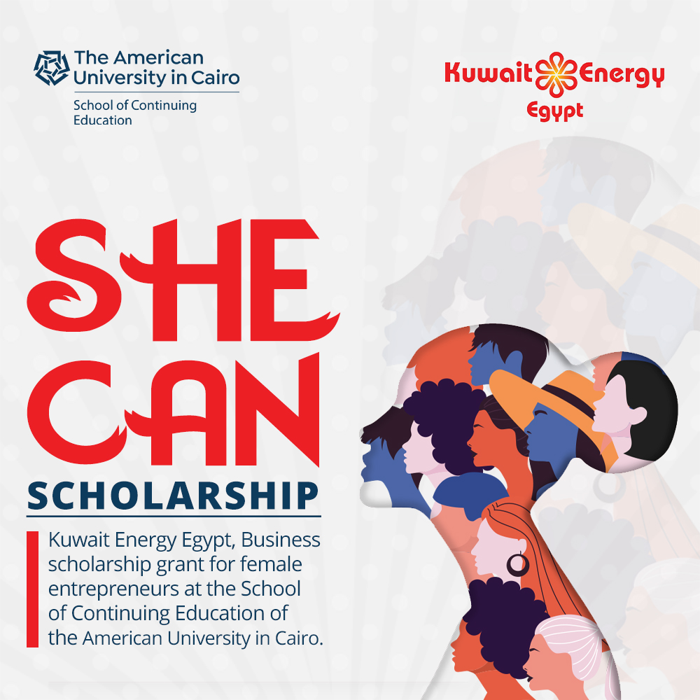

Kuwait Energy Egypt grants to support women entrepreneurs in "SHE CAN" Business Scholarship
Kuwait Energy Egypt partners with American University in Cairo, School of Continuing Education, “AUC SCE” to launch the inaugural SHE CAN Business Scholarship that grants for women entrepreneurs enabling them to acquire the essential knowledge and skills to successfully start-up and develop their own businesses.
SHE CAN Business Scholarship is fully-funded 3 months with 60 hours business scholarship for 50 Egyptian women participants, based in Egypt, aged between 25 to 40 and receives applications from women entrepreneurs providing them an intensive programme of microenterprise development training, mentoring, development support and business networking alongside in-depth coaching. The program will take place from February to April 2022. The graduates of the programme will receive the AUC SCE certificate of program’s completion after fulfilling successfully the requirements. The applicants still have the chance to register through AUC SCE platforms till Monday 10 January 2022.
Kamel Al Sawi, President of Kuwait Energy Egypt, said “Egyptian women have innovative business ideas. In line with Kuwait Energy’s commitment to closing the gender gap, we will provide them with the know-how and resources to manage successful business. By establishing the Kuwait Energy “SHE CAN” Business Scholarship, we will enable women entrepreneurs to discover and develop their entrepreneurial talent and to overcome the challenges they face in running their businesses”.
The Scholarship aims to create an entrepreneurial ecosystem that fosters growth, sustainability and resilience and address tomorrow’s opportunities by empowering women entrepreneurs thereby addressing several of the 17 Sustainable Development Goals and Egypt vision 2030.

