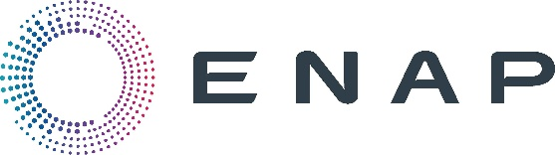

Enap Organized the First Successful Physical Scout Check Meeting After COVID-19 Pandemic

On December 15th Enap held the first physical Scout Check meeting after COVID-19 Pandemic in attendance of Eng. Abed Ezz El Regal, EGPC CEO, Denisse Abudinén Butto, CEO ENAP Sipetrol and General Manager ENAP Sipetrol Egypt branch, Geol. Adel Ahmed Samaha EGPC Deputy CEO for Exploration & Supervisor for Agreement Division, Dr. Samir Raslan EGAS Vice Chairman for Exploration & Agreement and most of IOCs, EGPC Exploration department leaders. The event, which took place at Dusit Thani Hotel in Cairo, was divided into three main parts: the first part Enap shared its history profile in Egypt since 1998 with different exploration activities in 5 blocks with focus on its drilling and production performance in East Ras Qattara Concession in the Western Desert and the latest seismic acquisition operations that took place in early 2021, through its joint venture (JV) Petroshahd over Shahd, Shahd SE, Diaa, and Al-Zahra Development leases.
In the second part of the event EGPC presented the current agreement activities. In addition, EUG (Egypt Upstream gateway) presented the 2021 EUG key activities highlighting the E&P community and concentrating on the technical insights of the current limited bid round on “North King Mariut “Block, Offshore Mediterranean. Finally, during the third part, Al Amal group presented the current Amal project for young professionals.

“Sharing the exploration activities among the oil & gas companies is very important as exploration is the core of our industry and I believe it will consequently affect positively in increasing the Oil & gas production as directed from H.E Minister Tarek El Molla” Eng. Abed Ezz El Regal, EGPC CEO, said. Also, Denisse Abudinén, CEO ENAP Sipetrol and General Manager ENAP Sipetrol Egypt branch stated: “As ENAP Sipetrol was our pleasure to hold the first Scout Meeting after COVID -19, all the governmental representatives and IOCs were very excited to share their experiences during this event, which was very successful to expand the exploration knowledge in the Oil & Gas Industry”.

